1.Addition and Subtraction:

# Program to find sum and difference

num1 = float(input("Enter first number: "))
num2 = float(input("Enter second number: "))

sum = num1 + num2
difference = num1 - num2

print("Sum is:", sum)
print("Difference is:", difference)

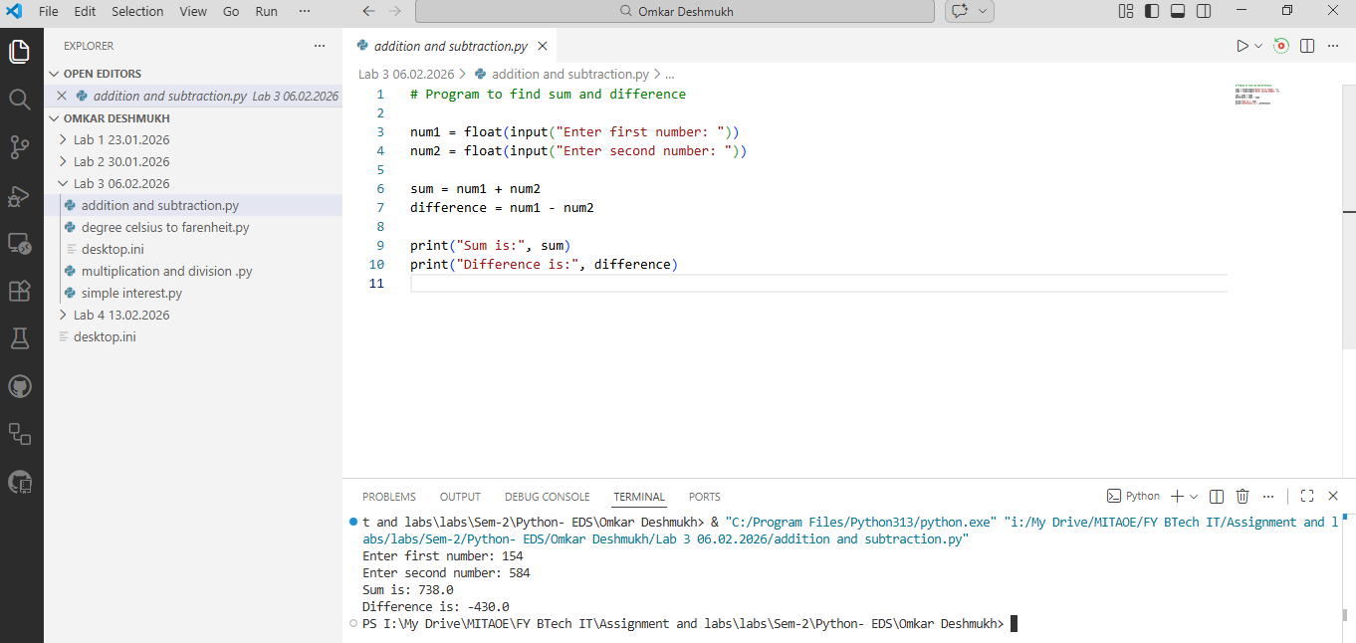

2.Multiplication and Division:
# Program to find multiplication and division

num1 = float(input("Enter first number: "))
num2 = float(input("Enter second number: "))

multiply = num1 * num2
division = num1 / num2

print("Multiplication is:", multiply)
print("Division is:", division)

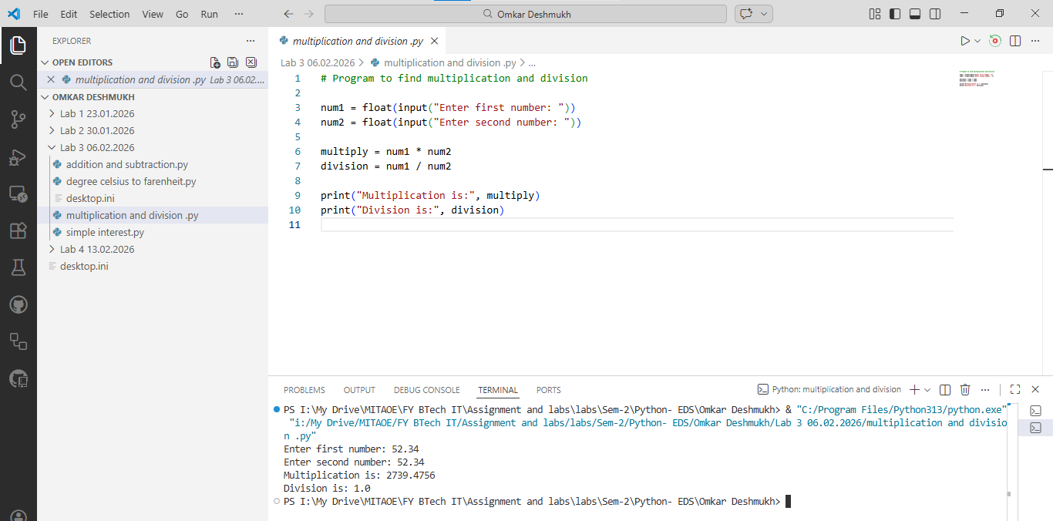

3.Simple Interest:
# Program to calculate Simple Interest

P = float(input("Enter Principal amount: "))
R = float(input("Enter Rate of interest: "))
T = float(input("Enter Time: "))

SI = (P * R * T) / 100
total = P + SI

print("Simple Interest is:", SI)
print("Total Amount is:", total)

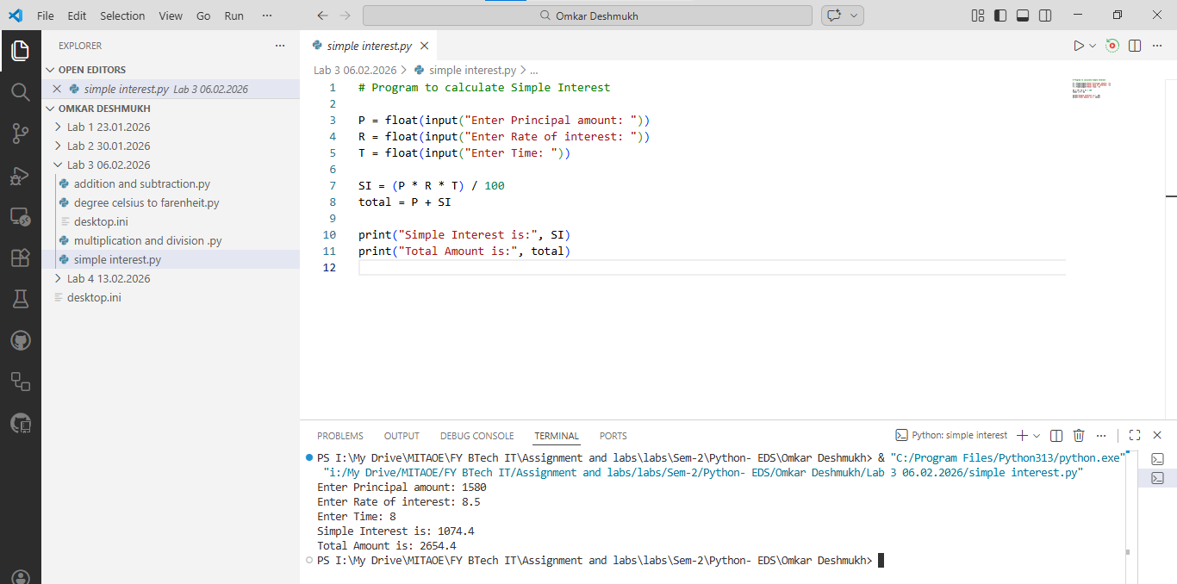

4. Degree Celsius To Fahrenheit:
# Program to convert Celsius to Fahrenheit

celsius = float(input("Enter temperature in Celsius: "))

fahrenheit = (9/5 * celsius) + 32

print("Temperature in Fahrenheit is:", fahrenheit)

